Electronics Documentation

Electronics Block Diagram
Oled Circuit Diagram (Console)
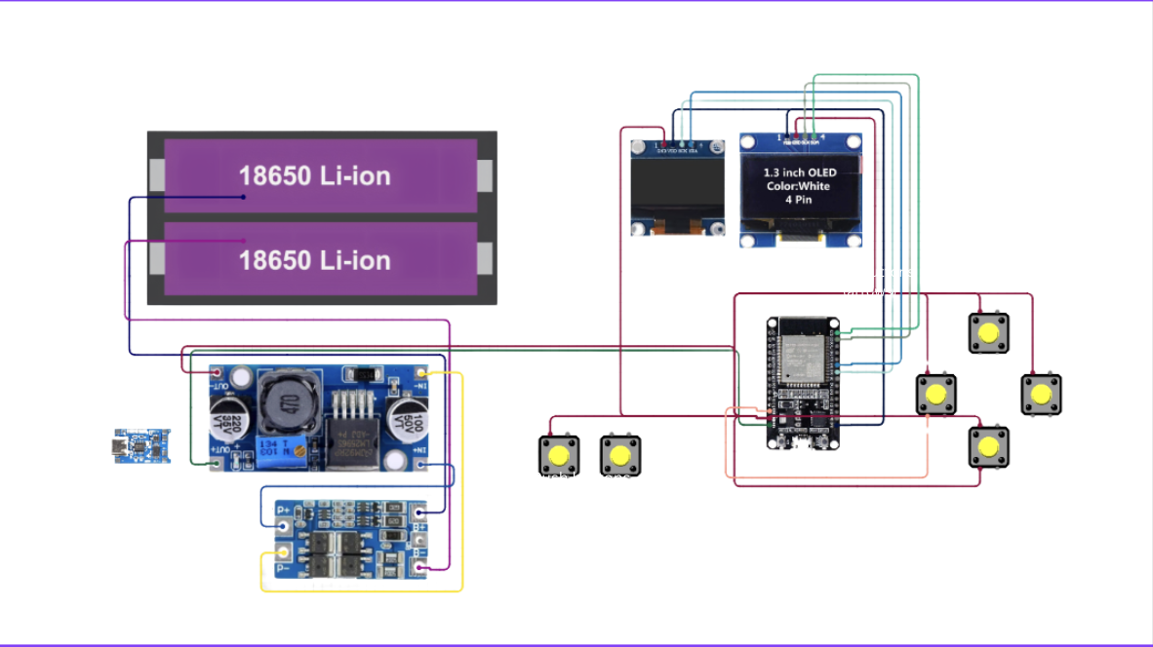

Doll Servos Circuit Diagram

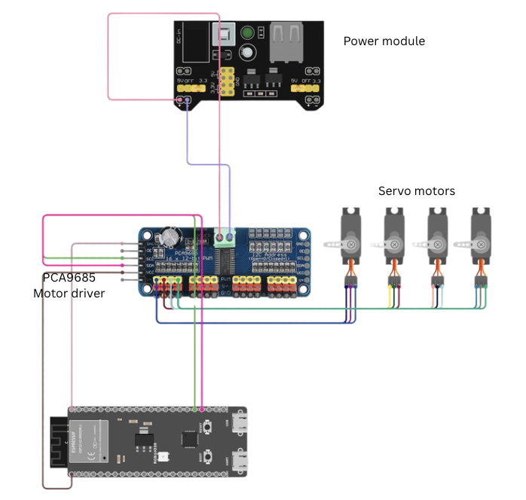

Console Circuit - OLED & Buttons
The console ESP32 manages input, display, and communication through a continuous loop.
Component | ESP32 Pin | Notes
OLED SCL (SSD1306) | GPIO 22 | I2C Clock
OLED SDA (SSD1306) | GPIO 23 | I2C Data
Right Arrow Button | GPIO 27 | INPUT_PULLUP
Down Arrow Button | GPIO 14 | INPUT_PULLUP
Up Arrow Button | GPIO 32 | INPUT_PULLUP
Left Arrow Button | GPIO 13 | INPUT_PULLUP
Start Button | GPIO 25 | INPUT_PULLUP
Stop Button | GPIO 26 | INPUT_PULLUP

2. Components Table
Component | Quantity | Purpose | Justification
ESP32 | 2 | Main controller for console and stage | Supports wireless (ESP-NOW), GPIO control, and flexible coding
1.3" OLED Display | 1 | Display game interface | Compact, low power, suitable for real-time visuals
Arrow Push Buttons | 4 | User input for gameplay | Simple, responsive directional control
Start/Stop Buttons | 2 | Control game flow | Improves usability and interaction
18650 Li-ion Battery Pack | 1 | Power supply | Portable and sufficient capacity for system
ESP-NOW Wireless (Sender/Receiver) | 2 | Communication between systems | Enables low-latency wireless data transfer
PCA9685 PWM Driver | 1 | Control multiple servos | Provides stable PWM signals beyond ESP32 limits
Servo Motors | 4 | Doll movement | Easy angle control for directional motion
Motor Power Module | 1 | Power distribution | Ensures adequate current for servos
Buzzer (Optional) | 1 | Feedback sound | Enhances user interaction and feedback

